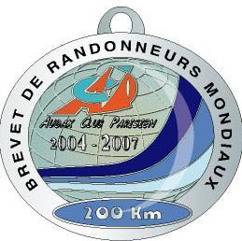
AUDAX CLUB PARISIEN
SUPER RANDONNEUR

MEDAL APPLICATION FORM
(to be filled in block letters PLEASE)

RANDONNEURS FRANÇAIS 1921
RANDONNEURS EUROPEENS 1976
RANDONNEURS MONDIAUX 1983

Nome: Sobrenome: Data nascimento:

Endereço:

CEP: Cidade: Estado: País:

Clube Nome: CLUBE AUDAX FLORIPA Código ACP do clube: 980033

(NO abbreviations)

Organization | BREVET | Date | Organizer  or name of the event | * ACP Brevet Number
Brevets de  Randonneurs  Mondiaux | 200
Brevets de  Randonneurs  Mondiaux | 300
Brevets de  Randonneurs  Mondiaux | 400
Brevets de  Randonneurs  Mondiaux | 600
* The ACP Brevet number can be found on the ACP sticker on your returned Brevet card.

